**Hw_03_ Shah*_*Niyati__Enhance_ICs__framework**

**Monochromatic Images:**

After examining all the three images, I could see that the best contrast was on the green channel when compared to others. (In the desired part).

After zooming into the regions we could see that the green and Luminance channel image showed a faint writing of the IC numbers better than HSV and Gray channel image.

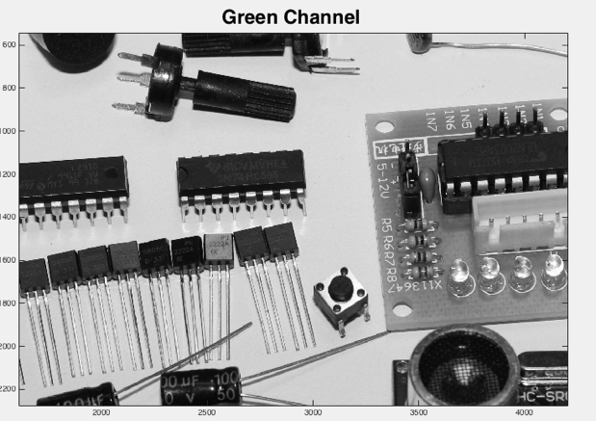 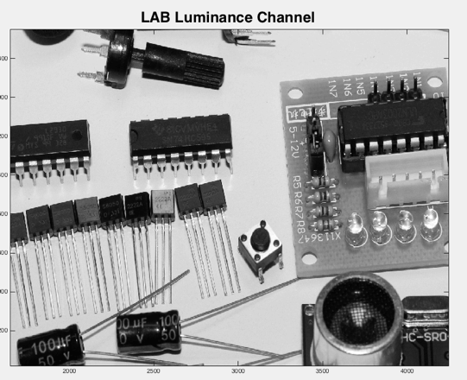

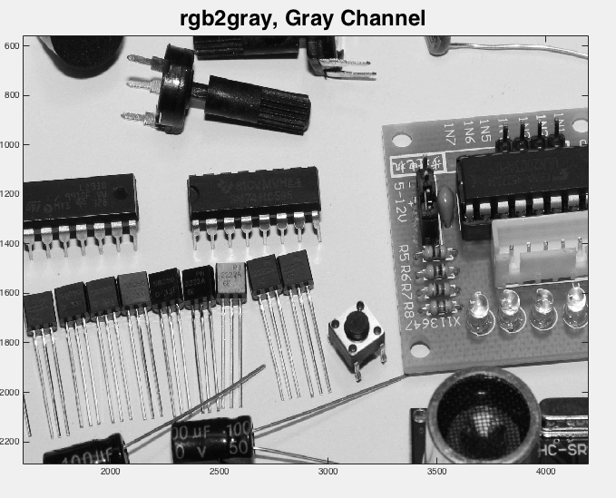 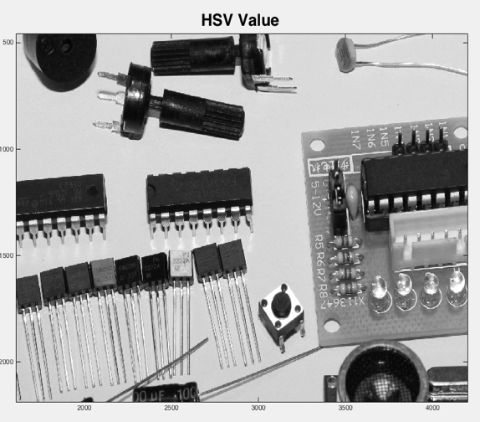

This was one of the reasons to go forward with the processing of the green and Luminance.

**Histograms:**

All the histograms looked very similar to each other, but after closer look there were some subtle differences that were visible in the image.

Like in HSV, there was a small peak in value between 0 and 0.2 and they were below 0.5 x105

While in other three there were sharper peaks and values were higher. The highest and sharpest peak was observed in the green channel.

The L channel of Lab had spikes between the values 0.7 and 0.75 while the others had a clean slope.

We can also see a curve between values 0.4-0.6 in the HSV channel histogram which is not present in the other histograms.

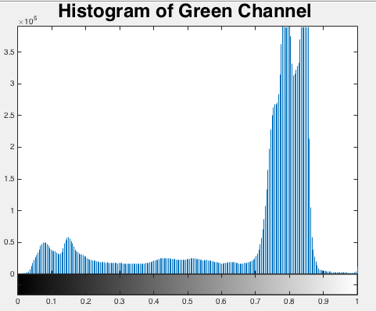 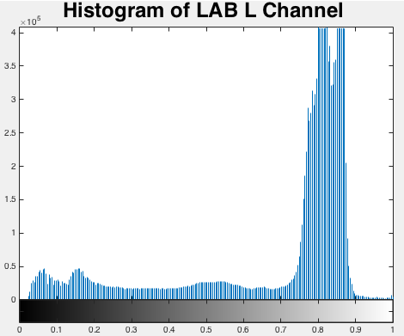

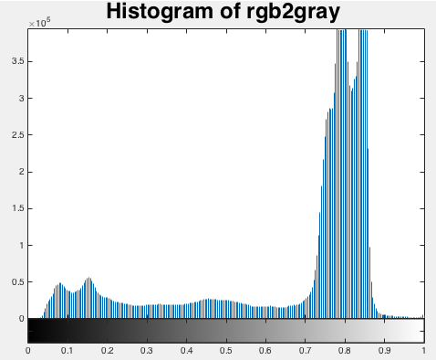 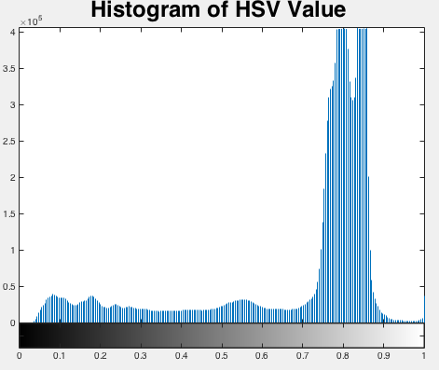

As we need to check the IC number from the ICs, which is black and grey, we needed an image which had higher and sharper values from the darker region to define the area.

This was the other reason why I went forward with the processing of green and Luminance channel image.

**Image Enhancement**

For the dark writing on the IC to stand out I performed a couple of image enhancement processes.

**Using Green channel image:**

**TEST**: I used histogram equalization to increase the contrast on the image and tried and tested with a couple of different clip values.

**Output:** The green color of the image was too bright and light and any change in clipping would not affect the contrast enough to show the writing.

Similarly, I tried using iamadjust and adapthisteq functions, but I got similar results with them.

Even though the the writing was a different color (whitish) but it was not clearly visible.

Or the information was lost in the details of black.

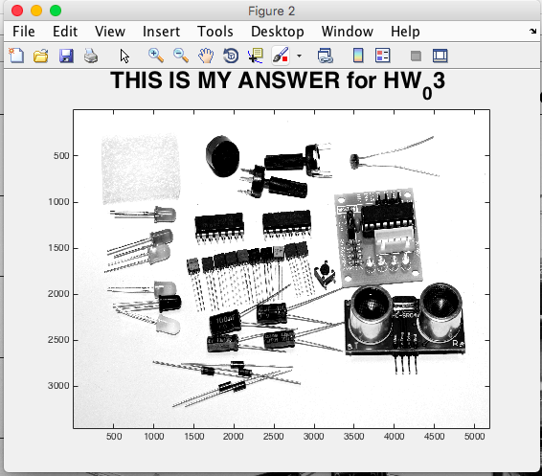

**Test:** So I tried to multiplying the green channel image with a different root value so as to increase the contrast with the image.

**Output**: I could see a difference in color but it was still whitish with a light green background making it difficult to see.

Next I tried to mix both the root value of the green channel with the functions iamadjust, adapthisteq and histeq.

Here again I saw a few changes which made me realize that I could mix all the channels together I could get a better contrast then using the green alone.

**Test**: Concatenated all the channels of the image back together with some processing on the green channel which is cube rooting and performing adapthisteq. I tried using a few different clip values on it.

**Solution**: I got a perfect image which had a good contrast between the IC board and the writing on it.

**Using Luminance channel image:**

Tried a similar approach with the L channel image, but again I got similar results where the words were lost in the black background.

Here I also tried adding numbers instead of multiplying by a root to see the different effects on the image. But I did not get a satisfactory answer.

**Using other channel images:**

Just to check the results, I also tried using the other channels but it did not get any satisfactory output in any of them.

**Other methods:**

I tried multiplying the image by various numbers like 1.5, 2 etc to see the output as multiplication increases the contrast of an image and also used addition subtraction, logarithmic function to see the different results.

But found that the best answer was by using the green channel, and applying adapthisteq function on the cube root of the green image and then concatenating this new formed green image with all the different channels of the input and clipping them by values 0.57 and 0.07.